New York State Education Department

K-3 Literacy Curriculum Review Guide

June 2024

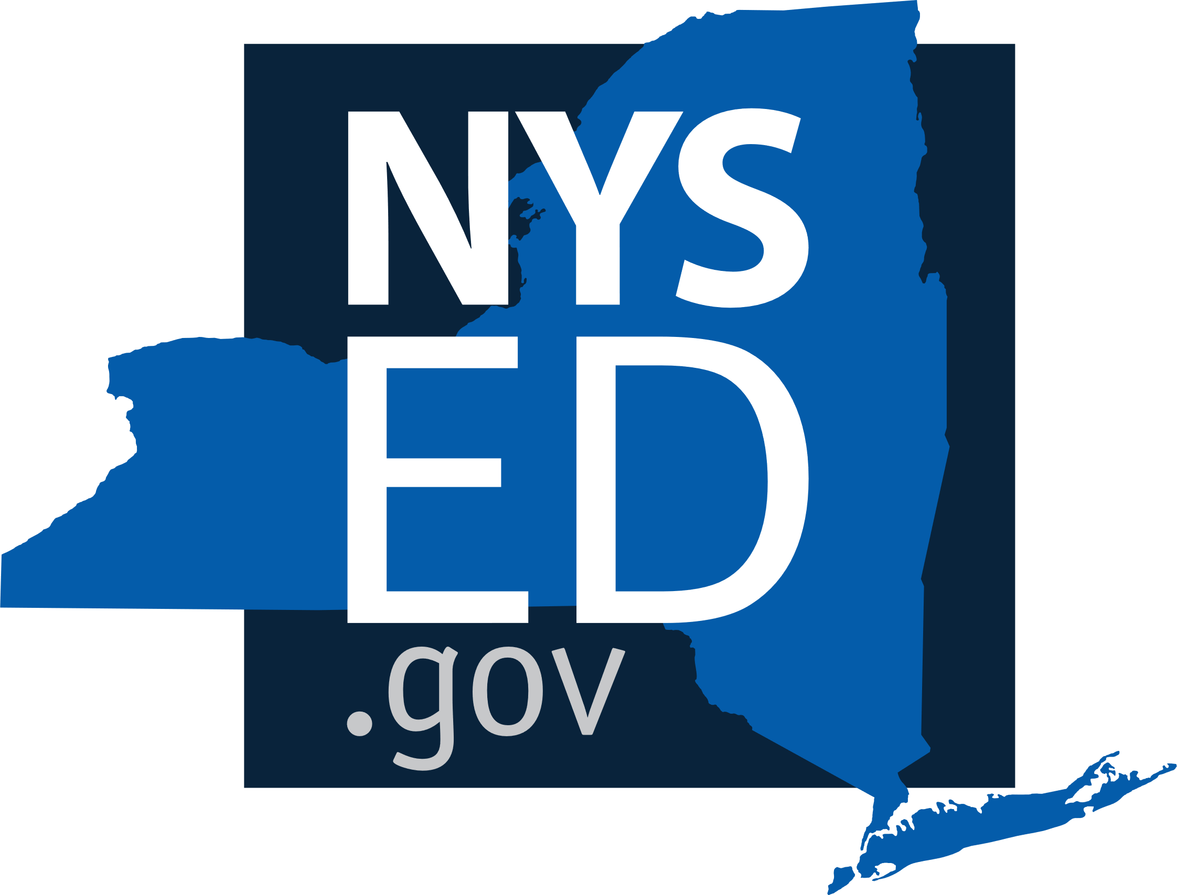

Organization of the Guide

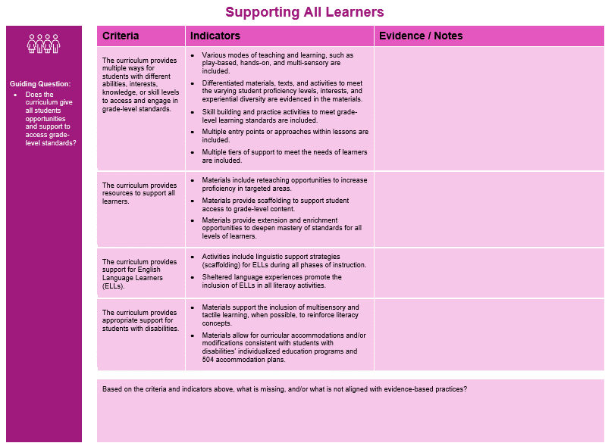
- Domain: The Guide is divided into five domains that categorize aspects of a high-quality literacy curriculum.
  - The order of the domains is not weighted by significance. All are important.
- Guiding Question(s): Anchor local discussion
- Criteria: Essential elements of a literacy curriculum
- Indicators: “Look fors” that delineate criterion
- Evidence / Notes: Intentionally blank to provide space for thoughts, questions, and comments
- Missing / Unaligned: An additional space to record criteria that is not found and/or to identify materials not aligned to evidence-based practices (or “red flags”).

Curriculum Review Domains
The K-3 Literacy Curriculum Review Guide is organized into the following five domains*:

* The order of the domains is not weighted by significance. All are important.

Learning Standards and Evidence-Based Practices

 |  | Criteria | Indicators | Evidence / Notes
Guiding Questions:  - Do students have access to grade-appropriate tasks and instruction aligned to Learning Standards?  - Does the curriculum provide systematic and explicit instruction with sufficient student practice to support reading foundational skills?  - Is the curriculum clear about what must be taught to reflect learning standards for each grade level? |  | The curriculum aligns with the appropriate grade-level NYS ELA Learning Standards. | - All grade-level ELA standards are cited and clearly identified in scope and sequence, curriculum maps, and lesson plans.
 |  | The curriculum reflects evidence-based, interdisciplinary scientific research on P-12 literacy development, known as the Science of Reading. | - The reading process is broken down into skills that are introduced systematically and consistently in a logical sequence.  - Lessons are organized to teach skills explicitly and directly.  - Objectives and examples are clear and specific.  - Learned skills are applied in an integrated manner through engagement with authentic reading and writing tasks.  - Texts are high-quality, developmentally appropriate, and culturally responsive.
 |  | The curriculum emphasizes explicit, systematic instruction of phonological awareness, including phonemic awareness. | - Phonemic awareness and phonological lessons have clear objectives, are introduced systematically, and are organized to teach knowledge and skills directly and explicitly.  - Larger phonologic units (e.g., syllable, rhyme) as well as phonemic units (e.g., consonant blends) are included.  - Stages of simple to advanced phonemic manipulation tasks (e.g., isolating, blending, deleting, substituting) are included.
 |  | The curriculum emphasizes explicit and systematic instruction of evidence-based phonics. | - Phonics lessons have clear objectives, are introduced systematically, and are organized to directly and explicitly teach knowledge and skills.  - Letter-sound-symbol association is taught sequentially, from least to most complex relationships.  - Phonetic decoding is emphasized, with attention to word structure.  - Decodable texts match the phonics skills being taught and selected according to the needs of the student.
 |  | The curriculum emphasizes explicit, systematic instruction of fluency. | - Fluency is a clear objective.  - Materials provide consistent opportunities for students to hear fluent oral reading of increasingly complex texts that lead to proficiency in both oral and silent reading.  - Oral reading is practiced at the word, sentence, and paragraph level, while being exposed to a variety of genres.
 |  | The curriculum emphasizes explicit, systematic instruction of comprehension. | - Comprehension lessons have clear objectives, are introduced systematically, and are organized to teach comprehension skills directly and explicitly.  - Clear connections are made to activate background knowledge and prior experiences.  - Materials provide exposure to complex texts in a variety of genres, (including but not limited to informational, literary, and poetry) with attention to building background knowledge, focusing on text structure to increase comprehension, and boosting student enjoyment.
 |  | The curriculum emphasizes explicit, systematic instruction of vocabulary. | - Vocabulary lessons have clear objectives, are introduced systematically, and are organized to teach the meaning of words directly and explicitly.  - Materials provide instruction in word meaning (both in isolation and within context).
 |  | The curriculum emphasizes explicit systematic instruction of oral language development. | - Materials provide sufficient time for high-ordered discussions, with a focus on conventions (e.g., tone, conversational flow) and the development of topic-related ideas and complete thoughts.
 |  | The curriculum emphasizes explicit systematic instruction of writing. | - Writing lessons have clear objectives, are introduced systematically, and are organized to teach the skills of writing directly and explicitly.  - Lessons focus on the characteristics of writing beyond physical scribing and conventions, including the development of ideas, organization, fluency, and word choice.  - Materials include a variety of paper types to help students learn print concepts, develop handwriting skills, increase writing stamina, and establish organization.  - Students write in a variety of genres and for a variety of audiences and purposes.
 |  | Based on the criteria and indicators above, what is missing, and/or what is not aligned with evidence-based practices?

Culturally Responsive & Social-Emotional Learning

Guiding Questions:  - Does the curriculum support an engaging, inclusive, and respectful learning environment for all?  - Does the curriculum provide students the opportunity to view other’s experiences, reflect on their own identity, and open doors to be immersed in the text? |  | Criteria | Indicators | Evidence / Notes
 |  | The curriculum enhances the capacity for students to view concepts, issues, events from the perspectives of diverse groups, including race/ethnicity, language, ability, etc. | - All backgrounds, cultures, and identities are acknowledged, reflected, and respected.  - Materials reflect a diversity of perspectives and voices.  - Examples of relationship building and/or conflict resolution among people from different backgrounds are highlighted.  - Materials provide opportunities to have conversations about differing perspectives and points of view.
 |  | The curriculum includes a balance of representation of people with multiple perspectives and identities including race/ethnicity, gender, language, ability, etc. | - Texts include a diversity of characters that span genres, affirm and broaden perspectives, and develop an inclusive community.  - Strengths and contributions of all individuals are recognized, including those from underrepresented or historically marginalized groups.  - Portrayals of diverse people and cultures are accurate and multi-dimensional.
 |  | Students’ languages, literacies, and cultural ways of being are authentically centered throughout the curriculum instead of being “add-ons.” | - An asset-based approach that affirms students’ backgrounds is exemplified in the materials.  - Diverse cultural and social backgrounds of all students are integrated.
 |  | The curriculum includes authentic opportunities for students to showcase their voices and learning experiences. | - An asset-based approach is used so that students have an opportunity for self-expression and connection to their lived experiences.  - A wide variety of learning modalities is supported in the materials.  - Demonstration of mastery can be expressed in multiple ways.
 |  | The curriculum offers opportunities for students to reflect on and practice core social and emotional skills. | - Texts and materials explore a range of emotions, allowing students to analyze how characters experience and express feelings.  - Stories feature characters who demonstrate active listening, perspective-taking, and empathetic behavior.  - Literature depicts goal-setting and perseverance as themes or through character experiences.  - Texts allow students to explore concepts of identity, agency, and belonging.
 |  | Based on the criteria and indicators above, what is missing, and/or what is not aligned with evidence-based practices?

Supporting All Learners

Guiding Question:  - Does the curriculum give all students opportunities and support to access grade-level standards? |  | Criteria | Indicators | Evidence / Notes
 |  | The curriculum provides multiple ways for students with different abilities, interests, knowledge, or skill levels to access and engage in grade-level standards. | - Various modes of teaching and learning, such as play-based, hands-on, and multi-sensory are included.  - Differentiated materials, texts, and activities to meet the varying student proficiency levels, interests, and experiential diversity are evidenced in the materials.  - Skill building and practice activities to meet grade-level learning standards are included.  - Multiple entry points or approaches within lessons are included.  - Multiple tiers of support to meet the needs of learners are included.
 |  | The curriculum provides resources to support all learners. | - Materials include reteaching opportunities to increase proficiency in targeted areas.  - Materials provide scaffolding to support student access to grade-level content.  - Materials provide extension and enrichment opportunities to deepen mastery of standards for all levels of learners.
 |  | The curriculum provides support for English Language Learners (ELLs). | - Activities include linguistic support strategies (scaffolding) for ELLs during all phases of instruction.  - Sheltered language experiences promote the inclusion of ELLs in all literacy activities.
 |  | The curriculum provides appropriate support for students with disabilities. | - Materials support the inclusion of multisensory and tactile learning, when possible, to reinforce literacy concepts.  - Materials allow for curricular accommodations and/or modifications consistent with students with disabilities’ individualized education programs and 504 accommodation plans.
 |  | Based on the criteria and indicators above, what is missing, and/or what is not aligned with evidence-based practices?

Measuring Learning

Guiding Questions:  - Do the curriculum-embedded assessments identify student strengths and areas for growth to guide instruction?  - Do the curriculum-embedded assessments measure student progress and achievement of standards?  - Does the curriculum include both formative assessments to provide ongoing feedback and inform instruction and summative assessments to evaluate student achievement at the end of a unit? |  | Criteria | Indicators | Evidence / Notes
 |  | The curriculum includes methods and resources to measure student progress. | - Varied formative and summative assessments such as performance tasks and rubrics are included to assess student progress toward learning standards and to inform instruction.  - Materials include frequent formative assessments used to identify students’ misconceptions and gaps in skills and content knowledge, as well as identifying students’ strengths and mastery of foundational skills.  - Annotated exemplars of student work illustrate various performance levels at different points during the school year.  - Guidance is provided on how to move students to the next level.
 |  | The curriculum-embedded assessments are aligned to NYS ELA Learning Standards. | - Curriculum-embedded assessments indicate the targeted Standards.  - Materials include summative assessments used to ascertain attainment of Standards.
 |  | Additional Consideration: Universal screening assessments are used to identify general strengths/needs and gauge overall progress relative to grade-level learning standards.
 |  | Additional Consideration: Diagnostic assessments are used to clarify and target the difficulties of individual students when the information provided by universal screening assessments is not sufficient to do so.
 |  | Based on the criteria and indicators above, what is missing, and/or what is not aligned with evidence-based practices?

Usability

Guiding Question:  - Does the curriculum provide support and guidance for teachers to effectively plan for instruction? |  | Criteria | Indicators | Evidence / Notes
 |  | The curriculum includes guidance and resources to build teachers’ knowledge and ability to implement the curriculum. | - Materials include rubrics, exemplars, or other resources to help teachers set clear expectations for students.  - Materials include a range of supports for teachers to help guide students’ learning progressions (e.g., teacher editions, concise teacher notes explaining learning progressions, and guidance for specific standards/lessons, including pacing).
 |  | The curriculum provides sufficient flexibility to meet the varied needs, abilities, and interests of the students served. | - Print and digital materials can be customized for local use and personalized learning.  - Materials provide teachers with guidance on how to be inclusive and responsive to the diverse needs and identities of students.  - Texts appeal to a variety of students’ interests and include those for varied purposes, such as teacher read alouds, choral reading, instructional reading, and independent reading.
 |  | The curriculum has systematic, explicit, evidence-based scope and sequence. | - Scope and sequence include foundational skills.  - Horizontal and vertical alignment are included in the materials.  - Pacing is reasonable and flexible, maximizing student understanding.
 |  | The curriculum is well-written, designed, and accurate. | - Materials are well organized and easy to use.  - The content can be completed within a regular school year.  - Materials include citations for current, academic, and relevant research that supports the design of the resources and lessons, and guides educator understanding and instruction.  - The materials do not contain grammatical or factual errors.  - The visual design is not distracting.
 |  | The curriculum provides strategies and resources for teachers to inform and engage parents, family members, and caregivers of all students. | - Multilingual resources are available for families and are written in family-friendly language, (e.g., unit summaries, newsletters, take-home tasks, etc.).  - Suggestions for how families and caregivers can support student achievement at home are included.
 |  | Digital materials are user-friendly for teachers and students. | - Materials are compatible with multiple internet browsers.  - Materials are compatible with multiple operating systems.  - Materials align with the guidelines for Universal Design for Learning.
 |  | Based on the criteria and indicators above, what is missing, and/or what is not aligned with evidence-based practices?

New York State Education Department

