Analyze: Survey Data

**Facilitator Guidance Document**

## Why It’s Important

* Surveys offer valuable insights that can drive school improvement. Key benefits include:
  + **Broad Reach:** Surveys are an efficient way to gather feedback from a large audience.
  + **Measuring Intangibles:** Surveys allow schools to collect data on difficult-to-measure factors, such as perceptions, morale, or climate.
  + **Tracking Progress:** Surveys allow schools to see gains over time. By asking the same question in subsequent surveys, the school can better understand if their efforts are achieving their desired impact.
  + **Honest Feedback:** The anonymous nature of surveys encourages stakeholders to provide candid feedback they might be reluctant to offer in person.
  + **Enhanced Collaboration:** Surveys create opportunities for dialogue between students, staff, and parents about school culture.
  + **Inform New Efforts:** Stakeholder surveys are crucial for understanding how past efforts were received before implementing new initiatives.

## How Survey Analysis Fits into the Improvement Planning Process

* The Survey Analysis occurs after the Data Variation activities and before the Student Interviews

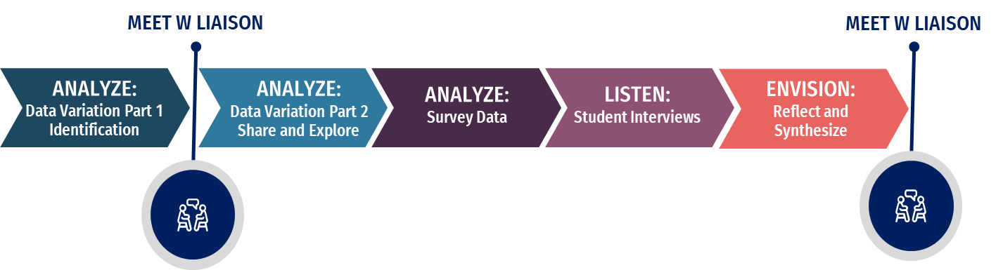

## Facilitator Guidance

### Potential for Customization

The facilitator can adjust the meeting structure or prompts as needed. Review the outline before the meeting to identify potential changes.

### Planning for Your Meeting

* Distribute survey data to participants before the meeting and encourage them to review it.
* To save time, share questions from the activity below so participants can prepare observations.
* Complete the **Survey Analysis Worksheet** once for Staff, Parent, and Student surveys.
* Teams may analyze surveys by focus areas based on the survey structure. If doing so, teams may benefit from completing multiple Survey Analysis Worksheets per survey.
  + Example: A team reviewing Student Survey data on Safety and then on Curriculum would complete two separate worksheets.
* **Tips for Effective Analysis:**
  + Start with quantitative data.
  + Account for statistical significance.
  + Distinguish between correlation and causation.
  + Compare current data with past data.

## Considerations for Schools Identified for ATSI and TSI

For schools identified for ATSI or TSI, the subgroup experience may differ significantly from the overall school experience. Be cautious when interpreting whole-school survey data.

* Example: If most students indicated that they feel safe, but a specific subgroup (e.g. Economically Disadvantaged) does not, it is incorrect to assume that the school has no safety issues. Subgroup experiences should be disaggregated. If that cannot be done, the team will want to consider additional ways of learning stakeholder perspectives on the subgroup experience, such as parent interviews and teacher focus groups.

## Considerations to Promote Equity and Inclusion

When analyzing survey data, ensure all voices are considered, particularly from underrepresented groups. Reflect on these questions:

* Are all stakeholder voices and perspectives represented? If not, how does this affect findings?
* Were there barriers to completing the survey? How does this influence the results?
* How do we address perspectives from those whose experiences differ from the majority?
* Where do themes of belonging, wellness, and hope emerge in the data?

Teams may also find the Department’s resources on [Culturally Relevant and Sustaining Practices](http://www.nysed.gov/crs/framework) helpful in exploring this topic further.

## Conducting Your Meeting

### Completing Survey Analysis Worksheets

1. **Distribute the Survey Analysis Worksheet** and have the team refer to the previously distributed Staff Survey data.

* Ensure everyone understands the data and how to review it.
* Review the Survey Analysis worksheet and question prompts. Emphasize that entries in the "Notice" column should focus on facts, not speculation.
* Caution against using speculative language like "because," "therefore," "it seems," and "however."

1. **Identify the Focus Area:** Surveys are often broken down into topics such as climate, culture, instructional practices, or leadership. As a team, decide which topic or focus area to examine first. If the survey lacks focus areas, consider reviewing all questions in the Staff Survey.
2. **Independent Review**: Ask participants to independently analyze the data and record their initial observations on the Survey Analysis worksheet.
3. **Group Discussion:** After a brief period for individual analysis, have participants discuss their observations in a large group or smaller groups.
4. **Report Findings:** Gather findings and consolidate them into one entry for the team. The facilitator can use visual aids (e.g., tick marks or stars) to highlight overlapping observations.
5. **Repeat for Additional Topics (Optional):** If desired, repeat steps 2–5 for a second focus area of the Staff Survey.
6. **Identify Trends:** After reviewing a second topic, complete the "Making Connections" section as a group to identify any trends across both focus areas.
7. **Repeat the Process for Other Surveys:** After completing the Staff Survey analysis, repeat the process for the Parent and Student Surveys.

### Completing the Survey Summary

After the team has completed at least one Survey Analysis worksheet per Staff, Student, and Parent Survey, ask the team to complete the Data Summary by looking across all three surveys.

# Survey Analysis Worksheet

**SURVEY:**

**FOCUS AREA**:

### Considering What the Data Reveals

|  |  |  |
| --- | --- | --- |
| **Prompts** | **Notice:**  *Only Facts - No Opinions* | **Wonder:**  *What questions do you have?*  *What do you need to know more about?* |
| Which questions received the most favorable responses? |  |  |
| Which questions received the least favorable responses? |  |  |
| If the data is disaggregated by subgroup, grade-level, etc., what similarities do we see in the responses of each group? |  |  |
| If the data is disaggregated by subgroup, grade-level, etc., are there areas where responses differ across the different groups? |  |  |
| Are there responses that surprised us? |  |  |
| Is there anything else that stands out when looking at this data? |  |  |
| How does this data compare to previous survey responses (if applicable)? |  |  |
| Is there anything here that helps us better understand the Data Variations we discussed earlier? |  |  |

### Making Connections

|  |
| --- |
| In looking at our responses, what connections or trends do we see within this survey data? |
|  |
| What connections or trends do we see across the other focus areas or surveys we have reviewed? |
|  |

# Survey Summary

|  |
| --- |
| After reviewing all our survey data, are there trends that are consistent across multiple stakeholder groups? |
|  |
| After reviewing all our survey data, are there trends that differ across stakeholder groups? |
|  |
| What did we learn from reviewing this data that we did not know before? |
|  |
| After reviewing our survey data, what questions remain that we want to explore further? |
|  |
| After reviewing our survey data, what other data might we want to review? |
|  |