Analyze: Data Variation Part 1: Identification

# Facilitator Guidance Document

## Why It’s Important

* Data variation can offer valuable insights during the Needs Assessment process. Teams that understand the patterns within the data can identify areas that may require additional attention and resources to drive continuous improvement.

## How This Activity Fits into the Improvement Planning Process

* Analyze: Data Variation is the first required activity within the Five-Part Needs Assessment process. There are two parts to the Analyze: Data Variation process:
  + First, the school leader will conduct Part 1: Identification
  + Then, the school leader will meet with the school’s NYSED or District liaison to discuss the findings from Part 1 and plan for how to approach Part 2 and the rest of the Needs Assessment.
  + Following that meeting, the SCEP Team will meet to explore the findings that came from Part 1.

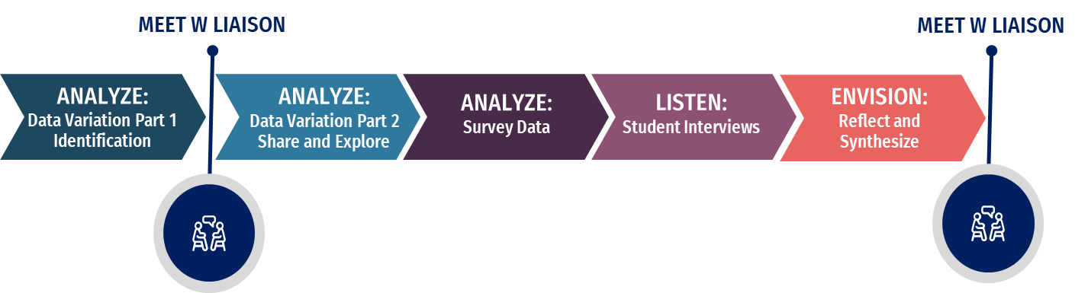

## Guidance for School Leaders

### Potential for Customization

* This activity involves examining a variety of data sources. Although designed for school leaders to complete, they may find it helpful to involve others in the process, provided that the school leader leads the activity.
* Because some parts of the data analysis involve looking at individual student-level data, privacy considerations may make it challenging to involve the entire SCEP team. The full team will be included in the *Part 2: Data Variation* discussion that occurs after the meeting with the school’s Liaison.

## Activity Scope

### Grade-Level Guidance

Schools that teach students in Elementary/Middle AND High School grades should focus on the grade band that has been identified for additional support.

### Subgroup-Level Guidance

Schools that have been identified for the Comprehensive Support and Improvement (CSI) support model should start with examining the data of ALL STUDENTS.

Schools that are in the Additional Targeted Support and Improvement (ATSI) support model should examine the data of the subgroup(s) that are identified for ATSI.

Schools that are in the Targeted Support and Improvement (TSI) support model should examine the data of the subgroup(s) that are identified for TSI.

Schools that have multiple support model classifications should start with the subgroup classification that is further along the support model continuum. For example, a school with one subgroup in ATSI and two subgroups in TSI would start with the ATSI subgroup.

# Elementary/Middle Data Variation Workbook

## Variation Investigation Part 1: Subject Performance Comparison

As a starting place, all school leaders should have an understanding of how the school/subgroup’s ELA performance compares to its Math performance. This understanding can inform subsequent inquiries as part of the Needs Assessment and ultimately inform the plan.

### STEPS:

1. Visit data.nysed.gov
2. Type the name of your school in the search box. Select your school from the list that appears.
3. Click “School Report Card.”
4. Under Accountability Data, **first** select “Core Subject Performance” and **then** select “Build Report”

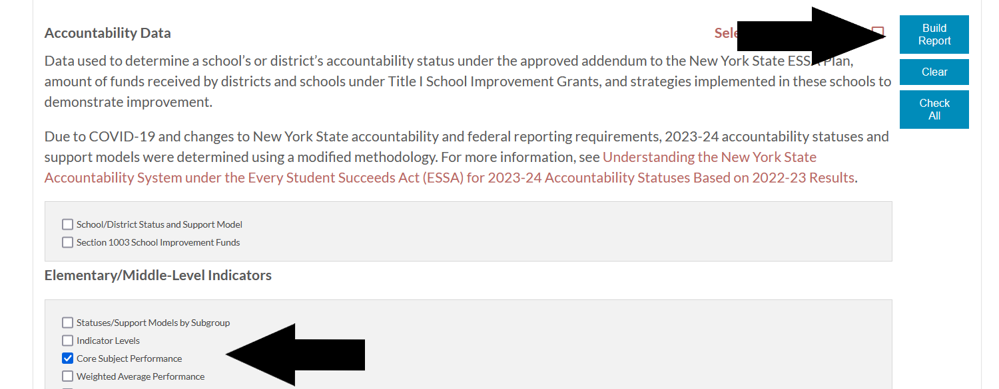

1. Note the Core Subject Performance Index for ELA and Math. This is the Performance Index that only examines the results of the students that took the State-level assessment. Enter the amounts in the table (Table 1.1) below.
2. Repeat steps 2 through 5 for 2022-23 and then 2021-22 to complete the rest of table 1.1. (Note that you will have to click the “Archive” link to access data from 2021-22)

### Table 1.1

**Subgroup:**

|  |  |  |  |  |
| --- | --- | --- | --- | --- |
|  | **ELA Performance Index** | **ELA State Avg** | **Math Performance Index** | **Math State Avg** |
| **2021-22** |  | 134.8 |  | 116.4 |
| **2022-23** |  | 134 |  | 138.7 |
| **2023-24** |  | 129.7 |  | 142.8 |

### Reflection Questions

1. What do you notice about how the ELA Performance Index compares to the Math Performance Index, especially in relation to the state averages?
2. What do you notice about the trajectory of the ELA Performance Index?
3. What do you notice about the trajectory of the Math Performance Index?
4. How do these trajectories align with the local data you have been collecting over the years?
5. The 2023-24 lowest and highest overall Core Subject Performance Indices within each Accountability Level are listed below. Where does your school/subgroup fall within these cut points for ELA and Math for 2023-24?

|  |  |  |  |  |  |  |  |  |  |  |
| --- | --- | --- | --- | --- | --- | --- | --- | --- | --- | --- |
| Accountability Level | **ALL STUDENTS**  **Min** | **ALL STUDENTS**  **Max** | **SWD**  **Min** | **SWD**  **Max** | **ELL**  **Min** | **ELL**  **Max** | **Econ Dis.**  **Min** | **Econ.**  **Dis.**  **Max** | **Race**  **Ethnicity**  **Min** | **Race**  **Ethnicity**  **Max** |
| 1 | 20 | 87.4 | 2.3 | 35.5 | 8.7 | 48.3 | 20 | 75.8 | 10 | 79.1 |
| 2 | 87.5 | 132.4 | 35.6 | 70.8 | 48.4 | 84.8 | 75.9 | 112.8 | 79.2 | 133.3 |
| 3 | 132.5 | 159.5 | 70.9 | 96.5 | 84.9 | 107.4 | 112.9 | 138.1 | 1334 | 167 |
| 4 | 159.6 | 244.2 | 96.6 | 228 | 107.5 | 222.6 | 138.2 | 238.9 | 167.1 | 246.9 |

## Variation Investigation Part 2: Grade Level Comparison

Variation may also exist between grades. Understanding this variation may be helpful in prompting deeper inquiries and ultimately developing targeted interventions.

### STEPS:

1. Visit data.nysed.gov and type in the name of your school.
2. Click on “School Report Card” under 2023-24.
3. Check Grades 3-8 English Language Arts and Grades 3-8 Mathematics under “Assessment Data”

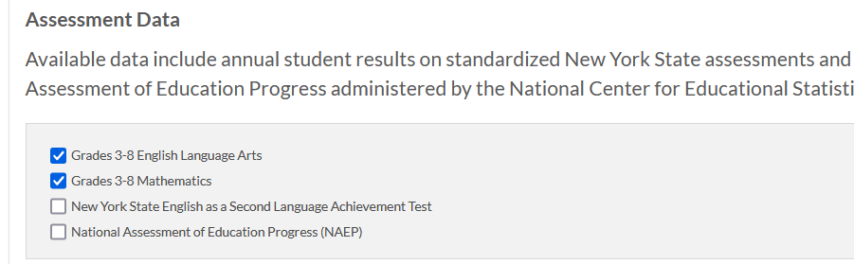

4. Click “Build Report”

5. Enter the % scoring Levels 1, 2, 3, and 4 for ELA for each grade level in Table 2.1

6. Enter the % scoring Levels 1, 2, 3, and 4 for Math for each grade level in Table 2.1.

*NOTE: for math grades 6-8, enter the percentages in the “Combined [Grade Level] ” row.*

### Table 2.1

**Subgroup:**

|  |  |  |  |  |  |  |  |  |
| --- | --- | --- | --- | --- | --- | --- | --- | --- |
| **GRADE**  **LEVEL** | **% Level 1**  **ELA** | **% Level 2**  **ELA** | **% Level 3**  **ELA** | **% Level 4**  **ELA** | **% Level 1**  **Math** | **% Level 2**  **Math** | **% Level 3**  **Math** | **% Level 4**  **Math** |
| **3** |  |  |  |  |  |  |  |  |
| **4** |  |  |  |  |  |  |  |  |
| **5** |  |  |  |  |  |  |  |  |
| **6** |  |  |  |  |  |  |  |  |
| **7** |  |  |  |  |  |  |  |  |
| **8** |  |  |  |  |  |  |  |  |

### Reflection Questions

1. Where are there variations between grades for ELA?
2. Where are there variations between grades for Math?
3. What else do you notice?

## Variation Investigation Part 3: Cohort Comparison

Variation between grades (Investigation Part 2) can be common, especially with smaller schools and subgroups. When you have identified variation in data, you will want to examine previous results to understand if any of the following are true:

1. Has this variation followed this cohort over the years, or is it new?
2. Is this variation occurring with the same grade level across multiple years, regardless of the cohort (e.g. when 5th grade students consistently outperform 4th grade students in math)?

### STEPS:

During Investigation #2, you identified the percent of students scoring Levels 1-4 in ELA and Math in 2023-24.

1. Enter the percentages from Investigation #2 in the corresponding 2023-24 row in Table 3.1. Depending on your grade configuration, you may not have entries for each row.
2. Go to data.nysed.gov and type in the name of your school.
3. Click on “2022-23” and “School Report Card”
4. Check Grades 3-8 English Language Arts and Grades 3-8 Mathematics under “Assessment Data,” then click “Build Report.”
5. Enter the percentages in the corresponding 2022-23 row in Table 3.1.
6. Repeat steps 3-5 with the 2021-22 School Report Card.

### Table 3.1

**Subgroup:**

|  |  |  |  |  |  |  |  |  |
| --- | --- | --- | --- | --- | --- | --- | --- | --- |
| **GRADE**  **LEVEL** | **% Level 1**  **ELA** | **% Level 2**  **ELA** | **% Level 3**  **ELA** | **% Level 4**  **ELA** | **% Level 1**  **Math** | **% Level 2**  **Math** | **% Level 3**  **Math** | **% Level 4**  **Math** |
| **4th grade**  **2023-24** |  |  |  |  |  |  |  |  |
| **3rd grade**  **2022-23** |  |  |  |  |  |  |  |  |

|  |  |  |  |  |  |  |  |  |
| --- | --- | --- | --- | --- | --- | --- | --- | --- |
| **GRADE**  **LEVEL** | **% Level 1**  **ELA** | **% Level 2**  **ELA** | **% Level 3**  **ELA** | **% Level 4**  **ELA** | **% Level 1**  **Math** | **% Level 2**  **Math** | **% Level 3**  **Math** | **% Level 4**  **Math** |
| **5th grade**  **2023-24** |  |  |  |  |  |  |  |  |
| **4th grade**  **2022-23** |  |  |  |  |  |  |  |  |
| **3rd grade**  **2021-22** |  |  |  |  |  |  |  |  |

|  |  |  |  |  |  |  |  |  |
| --- | --- | --- | --- | --- | --- | --- | --- | --- |
| **GRADE**  **LEVEL** | **% Level 1**  **ELA** | **% Level 2**  **ELA** | **% Level 3**  **ELA** | **% Level 4**  **ELA** | **% Level 1**  **Math** | **% Level 2**  **Math** | **% Level 3**  **Math** | **% Level 4**  **Math** |
| **6th grade**  **2023-24** |  |  |  |  |  |  |  |  |
| **5th grade**  **2022-23** |  |  |  |  |  |  |  |  |
| **4th grade**  **2021-22** |  |  |  |  |  |  |  |  |

|  |  |  |  |  |  |  |  |  |
| --- | --- | --- | --- | --- | --- | --- | --- | --- |
| **GRADE**  **LEVEL** | **% Level 1**  **ELA** | **% Level 2**  **ELA** | **% Level 3**  **ELA** | **% Level 4**  **ELA** | **% Level 1**  **Math** | **% Level 2**  **Math** | **% Level 3**  **Math** | **% Level 4**  **Math** |
| **7th grade**  **2023-24** |  |  |  |  |  |  |  |  |
| **6th grade**  **2022-23** |  |  |  |  |  |  |  |  |
| **5th grade**  **2021-22** |  |  |  |  |  |  |  |  |

|  |  |  |  |  |  |  |  |  |
| --- | --- | --- | --- | --- | --- | --- | --- | --- |
| **GRADE**  **LEVEL** | **% Level 1**  **ELA** | **% Level 2**  **ELA** | **% Level 3**  **ELA** | **% Level 4**  **ELA** | **% Level 1**  **Math** | **% Level 2**  **Math** | **% Level 3**  **Math** | **% Level 4**  **Math** |
| **8th grade**  **2023-24\*** |  |  |  |  |  |  |  |  |
| **7th grade**  **2022-23** |  |  |  |  |  |  |  |  |
| **6th grade**  **2021-22** |  |  |  |  |  |  |  |  |

### Reflection Questions

1. Where are there cohort variations for ELA?
2. Where are there cohort variations for Math?
3. What else do you notice?

## For Further Exploration

School leaders wishing to further understand State assessment data should work with their district to explore the variety of reports available through the [Cognos Student Information Reporting System (SIRS)](https://sdwcognos.nyseddata.org/).

**Level 1 Reports**

* Level 1 instructional reports can provide item analysis and trend information that may be useful to better understand the variations identified.

**Level 2 Reports**

* **SIRS 112 Growth Report** provides a capture of the individual growth results of each student from last year. This is calculated by first considering how individual students performed in 2022-23 and then comparing their 2023-24 results to the 2023-24 results of students who scored similar in 2022-23. These numbers indicate the percentile growth students had from the previous year. A student who has expected growth would be in the 50th percentile. This data can be useful when exploring potential variations in data.
* **SIRS 106 Elementary/Middle-Level Achievement Accountability Report** identifies how individual student results contributed to the school’s Performance Indices.

**Additional Level 2 Reports** may be useful in understanding student data. More information is available at: <https://p12.nysed.gov/irs/level2reports/home.html>

# High School Data Variation Workbook

## Investigation Part 1: Year-to-Year Regents Trajectory

In recognition that Regent results may vary within a school across the different exams, a helpful apples-to-apples comparison is to look at results on the same exam across multiple years to understand the trajectory of student performance for that subject.

### STEPS:

1. Visit data.nysed.gov and type in the name of your school in the search box. Select your school from the list that appears.
2. Click on “School Report Card” under 2023-24.
3. Click “Annual Regents Examinations” under “Assessment Data.”
4. Click “Build Report” on the right side of the page.
5. Input the percent of students scoring at each level in 2023-24 for the exams listed below in Table 1.1
6. Repeat steps 2-5 with the 2022-23 School Report Card.
7. Repeat steps 2-5 with the 2021-22 School Report Card (Note that you will have to click on the “Archive” link to access data from 2021-22.

### Table 1.1

**Subgroup:**

|  |  |  |  |  |  |
| --- | --- | --- | --- | --- | --- |
|  | **% Level 1 Algebra I Regents** | **% Level 2 Algebra I Regents** | **% Level 3 Algebra I Regents** | **% Level 4 Algebra I Regents** | **% Level 5 Algebra I Regents** |
| 2021-22 |  |  |  |  |  |
| 2022-23 |  |  |  |  |  |
| 2023-24 |  |  |  |  |  |

|  |  |  |  |  |  |
| --- | --- | --- | --- | --- | --- |
|  | **% Level 1 ELA Regents** | **% Level 2 ELA Regents** | **% Level 3 ELA Regents** | **% Level 4 ELA Regents** | **% Level 5 ELA Regents** |
| 2021-22 |  |  |  |  |  |
| 2022-23 |  |  |  |  |  |
| 2023-24 |  |  |  |  |  |

|  |  |  |  |  |  |
| --- | --- | --- | --- | --- | --- |
|  | **% Level 1 Living Environment Regents** | **% Level 2 Living Environment Regents** | **% Level 3 Living Environment Regents** | **% Level 4 Living Environment Regents** | **% Level 5 Living Environment Regents** |
| 2021-22 |  |  |  |  |  |
| 2022-23 |  |  |  |  |  |
| 2023-24 |  |  |  |  |  |

|  |  |  |  |  |  |
| --- | --- | --- | --- | --- | --- |
|  | **% Level 1 Global Regents** | **% Level 2 Global Regents** | **% Level 3 Global Regents** | **% Level 4 Global Regents** | **% Level 5 Global Regents** |
| 2021-22 |  |  |  |  |  |
| 2022-23 |  |  |  |  |  |
| 2023-24 |  |  |  |  |  |

### Reflection Questions

1. What do you notice about the different trajectories?
2. How do these trajectories align with the local data you have been collecting over the years?

## Investigation Part 2: Systems

Part 2 differs from Part 1, in that principals will explore reflective questions about systems, rather than input and analyze existing data. Schools have three options to pursue for Part 2:

1. School Connectedness
2. Attendance/Performance
3. Systems Self-Reflection

Principals will need to complete at least one of these options and extend the discussion with the full SCEP team following the meeting with their Liaison.

These investigations emphasize 9th grade data, consistent with research showing that success in 9th grade is a strong predictor of overall high school achievement.

* Studies highlight that the 9th-grade transition is **the most critical and manageable factor** in tackling the issue of high school dropout rates. [1]
* Research also indicates that 70 to 80 percent of students who fail any course in their first year are unlikely to graduate[2]
* Students that are off track at the end of 9th grade face significant challenges in getting back on track by the end of 10th grade compared to their peers.[3]

### School Connectedness

Experts have concluded that “[Students are more likely to succeed when they feel connect to school.](https://www.pcsb.org/cms/lib8/FL01903687/Centricity/Domain/202/national_strategy.pdf)” The overview “[Strengthening School Connectedness to Increase Student Success](https://files.eric.ed.gov/fulltext/ED656698.pdf)” provides a helpful primer on the topic.

**Reflection Questions:**

1. How do you measure School Connectedness at your school?
2. Knowing the importance of 9th grade, what does school connectedness look like for your current 9th grade using the measurement strategy you identified for question 1?
3. What might you want to consider as this group moves into 10th grade?
4. What might you want to consider for next year’s 9th graders?

### Attendance/Performance

High schools will want to establish systems that allow them to track live data and provide interventions throughout the year, rather than only analyze data at the end-of-the-year. Attendance and school performance are two variables that can be monitored on an ongoing basis and can be looked at together.

The Freshman Success Team at Sarah E. Goode STEM Academy in Chicago developed the following process outlined on the next page to take a staged approach to data. Initially, the team separates students with extremely low attendance from those attending semi-regularly, directing students with the most significant attendance issues to a group of attendance specialists. Next, the team uses GPA to identify students facing various academic challenges, creating targeted interventions both inside and outside the classroom to address their needs.[4]

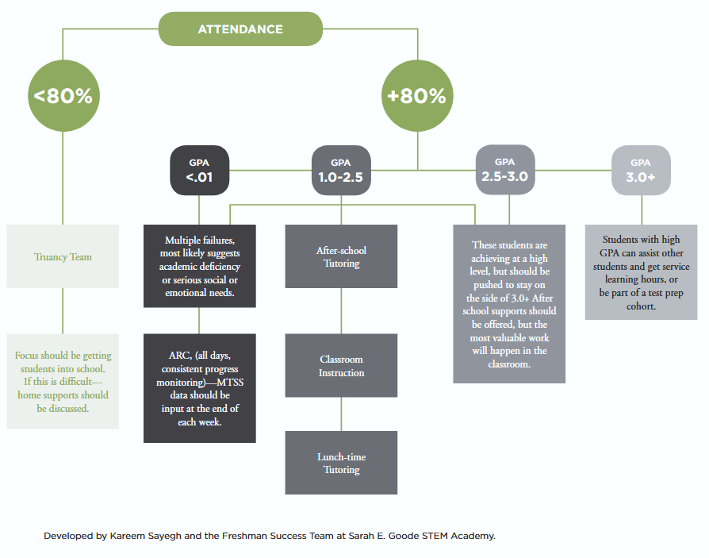

**Reflection Questions**

1. Do you have a team dedicated toward monitoring 9th grade success? If so, what data do they use? If not, how might you go about forming one?
2. What variables and what interventions would be useful for your team to monitor?

### Systems Self-Reflection

The Grad Partnership has developed a School Planning [Team Reflection and Action Planning Tool.](https://www.gradpartnership.org/resources/the-student-success-team-reflection-tool/)  The tool for Student Success Teams has four sections:

1. Supportive Community Relationships
2. Holistic, Real Time, Actionable Data
3. Adaptive Analysis, Response, and Improvement System
4. Shared Set of Student-Centered Mindsets

Principals pursuing the Systems Self-Reflection should plan on completing **Section 2: Holistic, Real Time, Actionable Data** with their full team during the *Analyze: Data Variation 2: Share and Explore* meeting. Teams may also complete the other sections if so desired.

## For Further Exploration

* School-level decisions can sometimes exacerbate the challenges of the 9th-grade transition instead of helping to alleviate them. Principals may want to examine existing data for their current 9th grade students to consider if changes to current systems would be beneficial for 9th graders:

1. **Teacher loads:** Ninth grade teachers tend to experience teacher loads as high—if not higher–than teachers in upper grades. Is that the case at your school?
2. **Teacher assignments:** It is not uncommon for novice teachers to be placed in 9th grade, while more experienced teachers are assigned upper-level students. As a result, 9th grade students are more likely to attend classes with less experienced teachers. Is that the case at your school?
3. **Class sizes:** Students in 9th grade can often be placed in classes with more students than in upper grades, limiting the opportunity for individualized attention. Is that the case at your school?
4. **Supports:** Students in 9th grade may not receive additional supports until after they have already failed a course. Is that the case in your school?

* The Education Resource Strategies report “[Transforming High School by Redesigning the Ninth Grade Experience](https://www.erstrategies.org/tap/transform-high-school/)” may be useful for principals to further explore ways to support 9th graders.
* School leaders wishing to further understand State assessment data should work with their district to explore the variety of reports available through the [Cognos Student Information Reporting System (SIRS)](https://sdwcognos.nyseddata.org/).

**Level 1 Reports**

* **Level 1** instructional reports can provide item analysis and trend information that may be useful to better understand the variations identified.

**Level 2 Reports**

* **Level 2 Reports** may also be useful in understanding student data. More information is available at: <https://p12.nysed.gov/irs/level2reports/home.html>

*NYSED does not endorse or approve the viewpoints presented in any of the external documents in this Activity. They are provided for informational purposes as resources developed by experts.*

1. Roderick, M., Kelley-Kemple T., Johnson, D.W. & Beechum, N.O. (2014). *Preventable Failure: Improvements in Long-Term Outcomes When High Schools Focused on the Ninth Grade Year: Research Summary*. Consortium on Chicago School Research at the University of Chicago. <https://consortium.uchicago.edu/publications/preventable-failure-improvements-long-term-outcomes-when-high-schools-focused-ninth>
2. Allensworth, A.M. & Easton, J.Q. (2005). *The On-Track Indicator as a Predictor of High School Graduation*. Consortium on Chicago School Research at the University of Chicago. <https://consortium.uchicago.edu/sites/default/files/publications/p78.pdf>
3. Strategic Data Project. (2012*). Are students who are off track to graduate in the ninth grade able to get back on track?* Center for Education Policy Research at Harvard University. <https://sdp.cepr.harvard.edu/files/cepr-sdp/files/sdp-spi-v2-off-track-memo.pdf>
4. Moeller, E., Seeskin, A. & Nagaoka, J. (2018). *Practice-Driven Data: Lessons from Chicago’s Approach to Research, Data, and Practice in Education*. Chicago, IL: UChicago Consortium on School Research. <https://ncs.uchicago.edu/sites/ncs.uchicago.edu/files/uploads/Practice-Driven-Data-Oct2018.pdf>