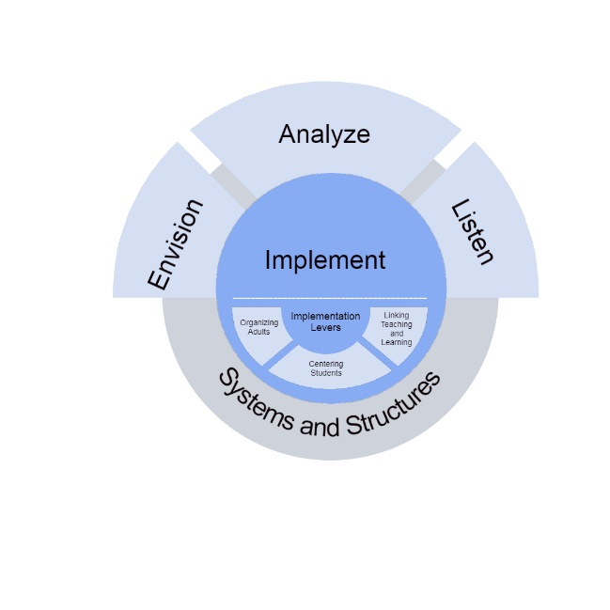

DCIP Planning Document for 2024-25 DCIP

District

Districts with No Identified Schools

A Message to District Leaders:
The District Comprehensive Improvement Plan (DCIP) Planning Document is designed to help districts consider the conditions within the district that need attention when developing the 2024-25 DCIP. This document is the district-level needs assessment that informs the final plan, and similar to the school-level needs assessment, the document is organized around NYSED’s core needs assessment concepts: Envision, Analyze, and Listen.
This document will involve:
- Analyze: Understanding Data
- Listen: Considering the Perspectives of the Identified Subgroup
- Envision: Reflecting on the District’s vision, values, and aspirations
NYSED encourages districts to be strategic in how they address their needs and to be mindful of the number of priorities and changes they attempt to address each year. When developing your 2024-25 DCIP, consider ways the priorities intersect so that the DCIP is aligned to support the pressing needs of the district. Rather than identifying multiple independent priorities within the DCIP, consider ways that priorities could be supported through a strategic approach that allows for the work being done in one area to support the work being done in another area.
Contents
Section 1: Analyze: Understanding Data 3
Section 1A: Local Data 3
Section 1B: Accountability Data 4
Section 2: Listen: Considering the Perspectives of the Identified Subgroup 7
Section 3: Envision: District’s Vision, Values, and Aspirations 8
Section 4: Putting it all Together 9
Priority 1: 9
Priority 2: 9
Priority 3: 9
Priority 4 (if applicable) 9
Priority 5 (if applicable): 10
NEXT STEPS 10

Section 1: Analyze: Understanding Data

Section 1A: Local Data
Use the space below to include at least five local data points that the District has collected that are relevant to understanding the District. These could include:
- State-collected data from the NYSED District Report Card, such as the teacher turnover rate
- School-collected data, such as walkthrough data or report card data
- District-collected data, such as survey results
- Districtwide academic assessment data
- Student engagement/attendance data
- Student social-emotional health data
As you review your district-level data, focus on variation in performance: “Understanding the sources of variation in outcomes, and responding effectively to them, lies in the heart of quality improvement.”¹ Select data that identifies areas where there is variation in outcomes (i.e., the performance in one area is not the same as the performance in another area). This could result in looking at variation within certain subjects (i.e., students perform better on some standards or skills compared to others), or variation within certain standards or skills (i.e., some students perform better on a certain standard than other students), or variation across classrooms, grade levels, or schools, or variation across groups of students. The job of team can then be to consider WHY those variations exist.

When possible, consider data from the 2023-24 school year.

District-level Data Reviewed | What We Noticed When Reviewing this Data
Example: Districtwide student survey data | 44% of students agreed that they do not feel challenged in class

Section 1B: Accountability Data
Background: Districts with no identified schools were identified as Target Districts last year when the subgroup performance of one or more subgroups was among the bottom 10% of districts for Core and Weighted Performance in Elementary/Middle Schools, or Core Performance, Weighted Performance, and Graduation Rate in High Schools. This section is designed to have districts review the data of the identified subgroup(s) at the district-level and at the school-level and identify where the district and school may have been in the bottom 10 percent.
Elementary/Middle
Districts that had a District-level subgroup among the lowest 10% of districts for Elementary/Middle Weighted Academic Performance received a Level 1 for this indicator. Did any subgroups in the district receive a Level 1 for this indicator? Check all that apply.

Economically Disadvantaged
English Language Learner
Students With Disability
Asian
Black
Hispanic
Native American
White

- Did the School-level subgroups of any Elementary/Middle Schools also receive a Level 1 for Weighted Academic Performance? If so, which one(s)?
School | Subgroup

Districts that had a District-level subgroup among the lowest 10% of districts for Elementary/Middle Core Academic Performance received a Level 1 for this indicator. Did any subgroups in the district receive a Level 1 for this indicator? Check all that apply.

Economically Disadvantaged
English Language Learner
Students With Disability
Asian
Black
Hispanic
Native American
White

- Did the School-level subgroups of any Elementary/Middle Schools also have a Level 1 for Core Academic Performance? If so, which one(s)?
School | Subgroup

High Schools
Districts that had a District-level subgroup among the lowest 10% of districts for High School Weighted Academic Performance received a Level 1 for this indicator. Did any subgroups in the district receive a Level 1 for this indicator? Check all that apply.

Economically Disadvantaged
English Language Learner
Students With Disability
Asian
Black
Hispanic
Native American
White

- Did the School-level subgroups of any High Schools also have a Level 1 for Weighted Academic Performance? If so, which one(s)?
School | Subgroup

Districts that had a District-level subgroup among the lowest 10% of districts for High School Core Academic Performance received a Level 1 for this indicator. Did any subgroups in the district receive a Level 1 for this indicator? Check all that apply.

Economically Disadvantaged
English Language Learner
Students With Disability
Asian
Black
Hispanic
Native American
White

- Did the School-level subgroups of any High Schools also have a Level 1 for Core Academic Performance? If so, which one(s)?
School | Subgroup

Districts that had a District-level subgroup among the lowest 10% of districts for High School Graduation Rate received a Level 1 for this indicator. Did any subgroups in the district receive a Level 1 for this indicator? Check all that apply.

Economically Disadvantaged
English Language Learner
Students With Disability
Asian
Black
Hispanic
Native American
White

- Did the School-level subgroups of any High Schools also have a Level 1 for Graduation Rate? If so, which one(s)?
School | Subgroup

- When looking at the subgroups that received Level 1s for performance and graduation rate across the district, what do you notice?

- When thinking about subgroup performance for your district, one of the things you will need to consider is the extent to which the identified subgroup experiences school differently than the subgroups that are not identified. When looking at the accountability levels assigned across your schools, how different are the identified subgroup’s levels compared to the other subgroups?

Section 2: Listen: Considering the Perspectives of the Identified Subgroup
Districts with no identified schools will need to incorporate a way to consider the perspectives of the identified subgroup. Examples of ways this could be accomplished include student shadowing, student interviews, focus groups, roundtable discussions, and surveys that disaggregate data by subgroup. Districts can determine how best to accomplish this and may pursue alternate means not listed among the examples.
Schools identified for TSI/ATSI/CSI support models are interviewing students in advance of writing their annual plans, and Districts with schools identified for these support models are being asked to reflect on the feedback provided during student interviews as part of their DCIP. Districts without identified schools may find the Department’s Student Interview resource helpful: https://www.nysed.gov/sites/default/files/programs/accountability/activity-4-listen-interviewing-students.pdf
How did the District seek out feedback from the identified subgroup?
What did the District learn from these students?

Section 3: Envision: District’s Vision, Values, and Aspirations
- What is the District’s vision?
- In recognition that sometimes vision statements may not be a current reflection of the District’s values and aspirations, is there anything else important to know about what the District values and aspires to be that is not captured in the current vision?
- Review your responses to Section 1 and Section 2 above. What themes emerged that let you know that you are on the right track toward the vision, values, and aspirations of the District?
- Review your responses to Section 1 and Section 2 above. What themes emerged that let you know that you still have work to do toward the vision, values, and aspirations of the District?

Section 4: Putting it all Together
Review your responses to Sections 1, 2, and 3 to identify 3 to 5 Priorities for the 2024-25 DCIP. Identify the Priorities below and indicate how those Priorities support the themes that emerged in the previous sections.

Priority 1:
What will the District prioritize to extend success in 2024-25?
This Priority helps support (indicate all that apply)
What was learned from our review of recent data (Section 1)
Themes from Students (Section 2)
The District’s Vision (Section 3, Question 1)
The District’s Values and Aspirations not captured through Vision (Section 3, Question 2)

Priority 2:
What will the District prioritize to extend success in 2024-25?
This Priority helps support (indicate all that apply)
What was learned from our review of recent data (Section 1)
Themes from Students (Section 2)
The District’s Vision (Section 3, Question 1)
The District’s Values and Aspirations not captured through Vision (Section 3, Question 2)

Priority 3:
What will the District prioritize to extend success in 2024-25?
This Priority helps support (indicate all that apply)
What was learned from our review of recent data (Section 1)
Themes from Students (Section 2)
The District’s Vision (Section 3, Question 1)
The District’s Values and Aspirations not captured through Vision (Section 3, Question 2)

Priority 4 (if applicable)
What will the District prioritize to extend success in 2024-25?
This Priority helps support (indicate all that apply)
What was learned from our review of recent data (Section 1)
Themes from Students (Section 2)
The District’s Vision (Section 3, Question 1)
The District’s Values and Aspirations not captured through Vision (Section 3, Question 2)

Priority 5 (if applicable):
What will the District prioritize to extend success in 2024-25?
This Priority helps support (indicate all that apply)
What was learned from our review of recent data (Section 1)
Themes from Students (Section 2)
The District’s Vision (Section 3, Question 1)
The District’s Values and Aspirations not captured through Vision (Section 3, Question 2)

NEXT STEPS
You have now completed the DCIP planning document. When developing your 2024-25 DCIP, please take into consideration your reflection on recent data, the District’s vision, values, and aspirations, and what the District learned when listening the identified subgroup to determine the best strategies to pursue. The Priorities identified in this document should correspond with the Priorities in your DCIP.
Districts may find it helpful to refer to the Improvement Planning materials available at: https://www.nysed.gov/accountability/improvement-planning when writing their plans. Districts may want to incorporate some of the resources available to schools as they explore their values and aspirations, analyze data, and identify goals, benchmarks and strategies.

Please submit this document to dcip@nysed.gov when you submit your 2024-25 DCIP.

