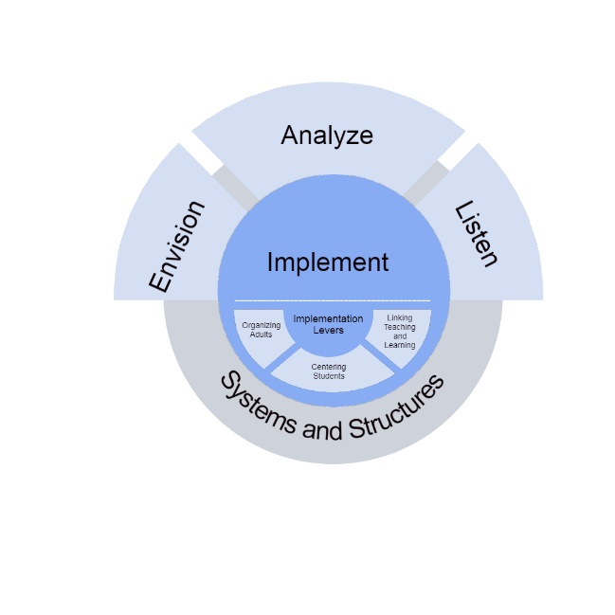

DCIP Planning Document for 2024-25 DCIP
District

A Message to District Leaders:
The District Comprehensive Improvement Plan (DCIP) Planning Document is designed to help districts consider the conditions within the district that need attention when developing the 2024-25 DCIP. This document is the district-level needs assessment that informs the final plan, and similar to the school-level needs assessment, the document is organized around NYSED’s core needs assessment concepts: Envision, Analyze, and Listen.
This document will involve:
- Envision: Reflecting on the District’s vision, values, and aspirations
- Listen: Reflecting on the 2024-25 SCEP Commitments made by schools within the District that are identified for TSI/ATSI/CSI support.
- Analyze: Understanding Local Data
- Analyze: Considering the effectiveness of the 2023-24 DCIP (Re-identified districts only)
NYSED encourages districts to be strategic in how they address their needs and to be mindful of the number of priorities and changes they attempt to address each year. When developing your 2024-25 DCIP, consider ways the Priorities intersect so that the DCIP is aligned to support the pressing needs of the district. Rather than identifying multiple independent Priorities within the DCIP, consider ways that Priorities could be supported through a strategic approach that allows for the work being done in one area to support the work being done in another area.
Contents
Section 1: District’s Vision, Values, and Aspirations 3
Section 2: School Commitments 4
Section 3: Understanding Local Data 5
Section 4: Considering What was Learned in 2023-24 (Re-Identified Districts Only) 6
Evaluating the Success of the 2023-24 DCIP 6
Considering the Effectiveness of Previous Resource Decisions 8
Section 5: Putting it all Together 9
Priority 1: 9
Priority 2: 9
Priority 3: 9
Priority 4 (if applicable) 9
Priority 5 (if applicable): 10
NEXT STEPS 10

Section 1: Envision: District’s Vision, Values, and Aspirations
- What is the District’s vision?
- In recognition that sometimes vision statements may not be a current reflection of the District’s values and aspirations, is there anything else important to know about what the District values and aspires to be that is not captured in the current vision?
- What themes emerged through the Envision-Analyze-Listen activities in your school(s) identified for TSI/ATSI/CSI support that let you know that you have made progress toward the vision, values, and aspirations of the District?
- What themes emerged through the Envision-Analyze-Listen activities in your school(s) identified for TSI/ATSI/CSI support that let you know that you still have work to be done toward the vision, values, and aspirations of the District?

Section 2: LISTEN: School Commitments
This section provides the opportunity for districts to consider what schools are indicating through their needs assessment and plan development process. To best position the district for success, NYSED strongly encourages that members of the school-level planning teams assist in developing the DCIP.
- Review the Commitments made in the SCEP(s) for your school(s) identified for TSI/ATSI/CSI support. What themes emerge when looking at the areas that are being prioritized for 2024-25?
- What Key Strategies are the schools prioritizing? How might the district create opportunities for schools to pursuing similar strategies to learn from one another?
- Based on your review of the Resources section for each Commitment in the SCEP(s), what do you envision to be the three to six largest expenses associated with the implementation of your SCEP(s)?
- Based on your review of the Resources section for each Commitment in the SCEP(s), what are the most effective ways for the District to use People to advance these Commitments, and, if applicable, to support improvement initiatives at other schools in the District?
- Based on your review of the Resources section for each Commitment in the SCEP(s), what are the most effective ways for the District to use Money, Space, and Time to advance these Commitments, and, if applicable, to support improvement initiatives at other schools in the District?

Section 3: ANALYZE: Understanding Local Data
Use the space below to include at least five local data points that the District has collected that are relevant to understanding the District. These could include:
- State-collected data from the NYSED District Report Card, such as the teacher turnover rate
- District-collected data, such as survey results
- Districtwide academic assessment data
- Student engagement/attendance data
- Student social-emotional health data

As you review your district-level data, focus on variation in performance: “Understanding the sources of variation in outcomes, and responding effectively to them, lies in the heart of quality improvement.”¹ Select data that identifies areas where there is variation in outcomes (i.e., the performance in one area is not the same as the performance in another area). This could result in looking at variation within certain subjects (i.e., students perform better on some standards or skills compared to others), or variation within certain standards or skills (i.e., some students perform better on a certain standard than other students), or variation across classrooms, grade levels, or schools, or variation across groups of students. The job of team can then be to consider WHY those variations exist.

When possible, consider data from the 2023-24 school year.

District-level Data Reviewed | What We Noticed When Reviewing this Data
Example: Districtwide student survey data | 44% of students agreed that they do not feel challenged in class

Section 4: ANALYZE: Considering What was Learned in 2023-24 (Re-Identified Districts Only)

Evaluating the Success of the 2023-24 DCIP
Refer to the 2023-24 DCIP to complete the information below.
Priority 1 in 2023-24 DCIP:
Was the District able to achieve the End-of-Year Success Criteria identified for this Priority?
If the identified success criteria were not achieved, in the space below, identify factors that may have contributed to the District not achieving these outcomes.
Factors

Priority 2 in 2023-24 DCIP:
Was the District able to achieve the End-of-Year Success Criteria identified for this Priority?
If the identified success criteria were not achieved, in the space below, identify factors that may have contributed to the District not achieving these outcomes.
Factors

Priority 3 in 2023-24 DCIP:
Was the District able to achieve the End-of-Year Success Criteria identified for this Priority?
If the identified success criteria were not achieved, in the space below, identify factors that may have contributed to the District not achieving these outcomes.
Factors

Priority 4 in 2023-24 DCIP (if applicable):
Was the District able to achieve the End-of-Year Success Criteria identified for this Priority?
If the identified success criteria were not achieved, in the space below, identify factors that may have contributed to the District not achieving these outcomes.
Factors

Priority 5 in 2023-24 DCIP (if applicable):
Was the District able to achieve the End-of-Year Success Criteria identified for this Priority?
If the identified success criteria were not achieved, in the space below, identify factors that may have contributed to the District not achieving these outcomes.
Factors

After reviewing your success in achieving the 2023-24 DCIP Priorities, what lessons have you learned that can be incorporated into your 2024-25 DCIP?

Considering the Effectiveness of Previous Resource Decisions
Identify the top three areas where the District directed its 2023-24 Title 1 1003(a) District-level Improvement Funds.
#1 Recipient/Use of District Improvement Funds:
What was your goal in directing funds in this manner?
Have you met this goal? How do you know?
What practices (including student practices and teacher practices) look different in the District now as a result of this expenditure?

#2 Recipient/Use of District Improvement Funds:
What was your goal in directing funds in this manner?
Have you met this goal? How do you know?
What practices (including student practices and teacher practices) look different in the District now as a result of this expenditure?

#3 Recipient/Use of District Improvement Funds:
What was your goal in directing funds in this manner?
Have you met this goal? How do you know?
What practices (including student practices and teacher practices) look different in the District now as a result of this expenditure?

After considering the effectiveness of previous resource allocation decisions, what lessons have you learned that can be incorporated into your 2024-25 DCIP?

Section 5: Putting it all Together
Review your responses to sections 1, 2, 3, and 4 to identify 3 to 5 Priorities for the 2023-24 DCIP. Identify the Priorities below and indicate how those Priorities support the themes that emerged in the previous sections.

Priority 1:
What will the District prioritize to extend success in 2024-25?
This Priority helps support (indicate all that apply)
The District’s Vision (Section 1, Question 1)
The District’s Values and Aspirations not captured through Vision (Section 1, Question 2)
Themes from the Envision-Analyze-Listen activities (Section 1, Questions 3-4)
Commitments made by our school(s) identified for TSI/ATSI/CSI support (Section 2, Question 1)
What was learned from our review of recent data (Section 3)
What was learned in 2023-24 (Section 4)

Priority 2:
What will the District prioritize to extend success in 2024-25?
This Priority helps support (indicate all that apply)
The District’s Vision (Section 1, Question 1)
The District’s Values and Aspirations not captured through Vision (Section 1, Question 2)
Themes from the Envision-Analyze-Listen activities (Section 1, Questions 3-4)
Commitments made by our school(s) identified for TSI/ATSI/CSI support (Section 2, Question 1)
What was learned from our review of recent data (Section 3)
What was learned in 2023-24 (Section 4)

Priority 3:
What will the District prioritize to extend success in 2024-25?
This Priority helps support (indicate all that apply)
The District’s Vision (Section 1, Question 1)
The District’s Values and Aspirations not captured through Vision (Section 1, Question 2)
Themes from the Envision-Analyze-Listen activities (Section 1, Questions 3-4)
Commitments made by our school(s) identified for TSI/ATSI/CSI support (Section 2, Question 1)
What was learned from our review of recent data (Section 3)
What was learned in 2023-24 (Section 4)

Priority 4 (if applicable)
What will the District prioritize to extend success in 2024-25?
This Priority helps support (indicate all that apply)
The District’s Vision (Section 1, Question 1)
The District’s Values and Aspirations not captured through Vision (Section 1, Question 2)
Themes from the Envision-Analyze-Listen activities (Section 1, Questions 3-4)
Commitments made by our school(s) identified for TSI/ATSI/CSI support (Section 2, Question 1)
What was learned from our review of recent data (Section 3)
What was learned in 2023-24 (Section 4)

Priority 5 (if applicable):
What will the District prioritize to extend success in 2024-25?
This Priority helps support (indicate all that apply)
The District’s Vision (Section 1, Question 1)
The District’s Values and Aspirations not captured through Vision (Section 1, Question 2)
Themes from the Envision-Analyze-Listen activities (Section 1, Questions 3-4)
Commitments made by our school(s) identified for TSI/ATSI/CSI support (Section 2, Question 1)
What was learned from our review of recent data (Section 3)
What was learned in 2023-24 (Section 4)

NEXT STEPS
You have now completed the DCIP planning document. When developing your 2024-25 DCIP, please take into consideration your reflection on the District’s vision, values, and aspirations, the Commitments selected by the school(s) in your district that are identified for TSI/ATSI/CSI support, and what the District learned from the past school year to determine the best strategies to pursue. The Priorities identified in this document should correspond with the Priorities in your DCIP.
Districts may find it helpful to refer to the Improvement Planning materials available at: https://www.nysed.gov/accountability/improvement-planning when writing their plans. Districts may want to incorporate some of the resources available to schools as they explore their values and aspirations, analyze data, and identify goals, benchmarks and strategies.

Please submit this document to dcip@nysed.gov when you submit your 2024-25 DCIP.

